**CENWP-OD-B 20 July 2023**

**MEMORANDUM FOR THE RECORD**

**SUBJECT: 23BON062 MFR AFF Valve 15 Lamprey and Salmonid Mortalities**

On the morning of 20 July, Columbia River Inter-Tribal Fish Commission (CRITFC) Biologists notified Bonneville Project Biologists of four lamprey mortalities, one juvenile chinook mortality, and one sockeye mortality found on the valve 15 trash rack in the Adult Fish Facility (AFF). The fish were scanned for PIT tags, inspected, and returned to the river.  
  
#1

1. Species – Pacific Lamprey (*Entosphenus tridentatus)*
2. Origin – Unknown
3. 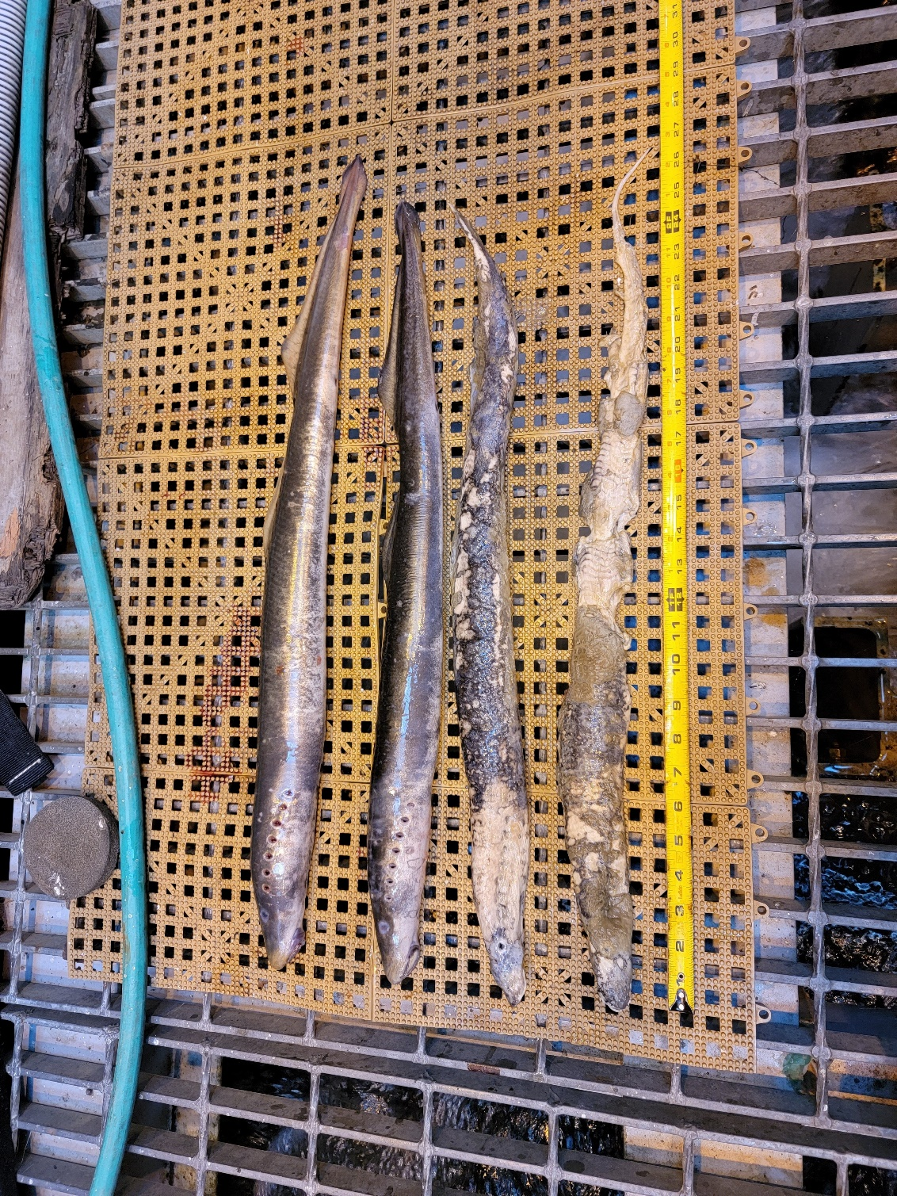Length – In descending order in the picture: 72.1 cm, 66.8 cm, 67.6 cm, 61 cm
4. Marks and tags – None
5. Marks and Injuries found on carcass – General decay
6. Cause and Time of Death – Unknown
7. Future and Preventative Measures – None

#2

1. Species – Chinook Salmon (*Oncorhynchus tshawytscha*)
2. 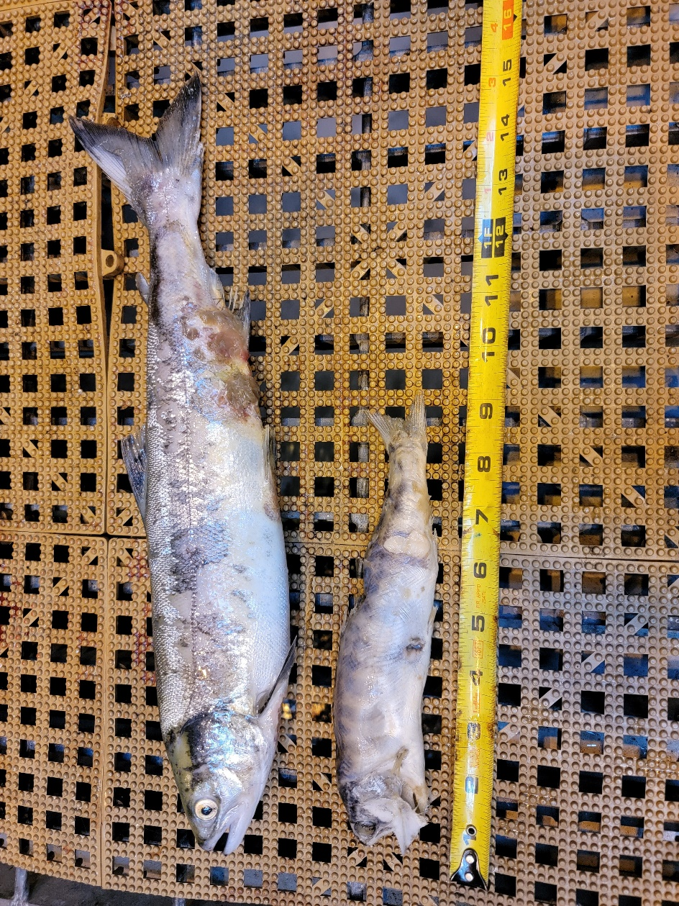Origin – Unknown
3. Length –22.9 cm
4. Marks and tags – None
5. Marks and Injuries found on carcass – Slight spine deformity
6. Cause and Time of Death – Unknown

#3

1. 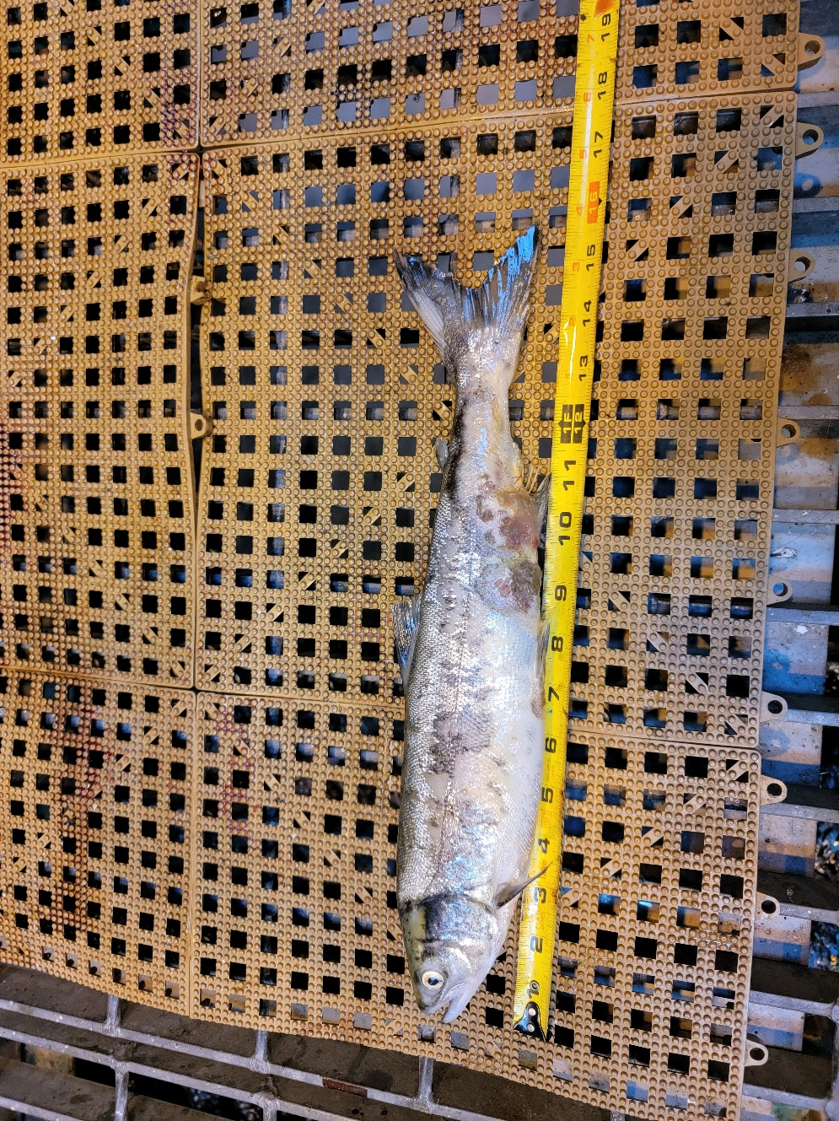Species – Sockeye Salmon (*Oncorhynchus nerka*)
2. Origin – Unknown
3. Length –39.4 cm
4. Marks and tags – None
5. Marks and Injuries found on carcass – general decay
6. Cause and Time of Death – Unknown

Sincerely,

Project Fisheries